
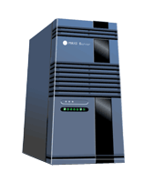
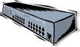
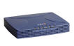

Browser
Internet
PC (6)
File Server
Hub / Switch
Cable Modem
PC (6)
Investment Office
Shared Printer
s

